Balises INPUT
ICS3C – Activité 3.4 – Piste d’exploration 1
Information tirée du site Web suivant : http://www.startyourdev.com/html/tag-html-balise-input.
Rendu des principaux types de la balise input
» type button
<input type="button" value="Clic !" /> | 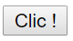
<input type="button" value="Clic !" style="color:red; font-weight:bold; padding:5px 10px;" />
<input type="button" value="Clic !" style="cursor:pointer; padding:5px 20px; background-color:lightsteelblue; border:dotted 2px grey; border-radius:5px;" /> | 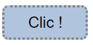
<input type="button" value="Clic !" style="width:100px; height:100px; border:solid 1px black; border-radius:51px;" /> | 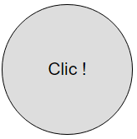
» type checkbox
<input type="checkbox" value="valeur" />
<input type="checkbox" id="IdCheckBox" value="valeur" />  <label for="IdCheckBox">Texte CheckBox</label> | Text CheckBox
<input type="checkbox" id="chkbox1" value="oui" />  <label for="chkbox1">oui</label>  <input type="checkbox" id="chkbox2" value="non" />  <label for="chkbox2">non</label>  <input type="checkbox" id="chkbox3" value="la réponse D" />  <label for="chkbox3">la réponse D</label> | oui  non  la réponse D
» type color
<input type="color" />
<input type="color" value="#dedede" />
<input type="color" value="#3377aa" onchange="document.getElementById('selColor').innerHTML = this.value;" />  <span id="selColor">Couleur : #3377aa</span> | 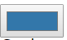  Couleur : #3377aa
» type date
<input type="date" /> | 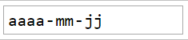
<input type="date" value="2012-12-25" /> | 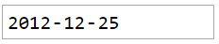
<input type="date" min="2012-12-01" max="2012-12-31" /> | 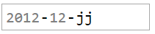
<input type="date" value="2012-12-25" style="padding:5px; border:solid 1px black; color:steelblue; border-radius:5px;" /> | 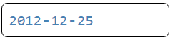
» type file
<input type="file" style="width:200px; font-size:10px;" /> | 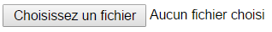
<input type="file" style="width:200px; font-size:10px; color:red;" /> | 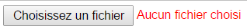
» type image
<input type="image" src="exemple.png" style="height:80px;" />
<input type="image" src="exemple.png" style="height:80px; border:solid 1px silver; border-radius:10px;" />
<input type="image" src="exemple.png" style="margin:10px; height:80px; border-radius:10px; box-shadow:0 0 15px 2px;" />
» type number
<input type="number" />
<input type="number" min="0" max="10" value="100" step="5" onkeypress="return false;" />
» type password
<input type="password" value="password" />
<input type="password" value="password" style="border:solid 1px black; border-radius:5px; text-align:center;" />
<input type="password" value="password" style="border:solid 1px black; border-radius:5px; text-align:center; box-shadow:0 0 6px;" />
» type radio
<input id="rad1" name="radGroupe" type="radio" value="oui" />  <label for="rad1">oui</label>  <input id="rad2" name="radGroupe" type="radio" value="non" />  <label for="rad2">non</label>  <input id="rad3" name="radGroupe" type="radio" value="la réponse D" />  <label for="rad3">la réponse D</label> | oui  non  la réponse D
» type range
<input type="range" />
<input type="range" min="0" max="100" step="5" value="0" />  <span id="selRange">0</span> | 0
» type text
<input type="text" value="Exemple" />
<input type="text" placeholder="Saisie libre" />
<input type="text" value="Exemple" style="border:solid 1px black; border-radius:5px; text-align:center; box-shadow:0 0 6px;" />
<input type="text" value="Exemple" style="border:solid 1px steelblue; text-transform:uppercase; font-weight:bold; color:steelblue;" />

